Kubernetes Installation In AWS

The Kubernetes is an open-source project started by Google in 2014. It helps in [automating deployment](http://www.tothenew.com/devops-aws), scaling and operations of application containers across clusters of hosts.

**Setup Kubernetes Cluster on AWS EC2:**

1. You can either setup AWSCLI on your local machine or launch a new EC2 instance with IAM role that has administrator access.
2. Create a new role with Administrator Access. Note: Workstation requires administrator access to create new IAM roles (i.e. kubernetes-master and kubernetes-minion) that are assigned to newly created master and minions nodes.

**Creating new role:**

1. **Click on “my security credentials” in the AWS console**

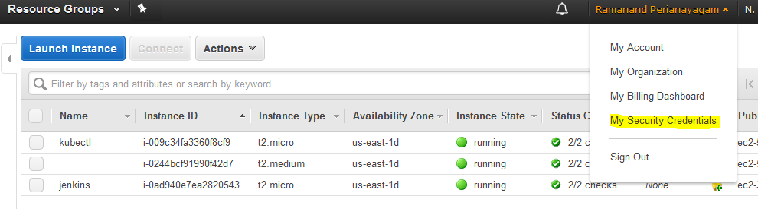

1. **Click “Roles”**

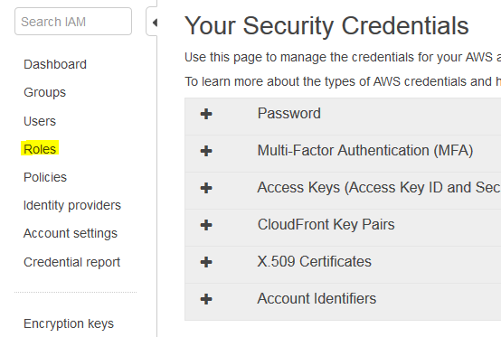

1. **Click “create new roles”**
2. **Select role type – Amazon EC2**

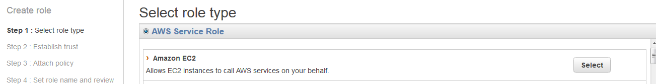

1. **Attach policy**

Select one or more policies to attach. Each role can have up to 10 policies attached.

Select below listed policies

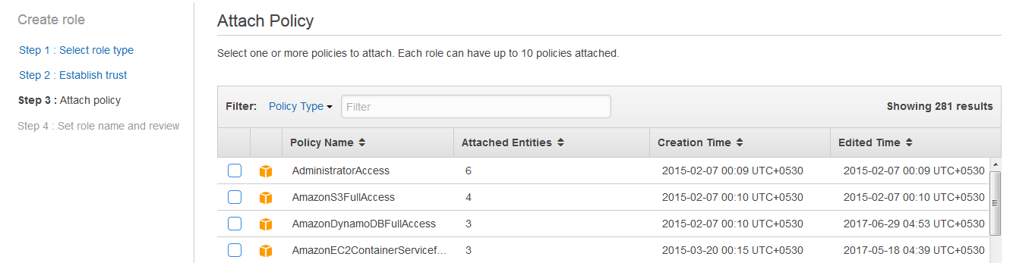

* [AmazonEC2FullAccess](https://console.aws.amazon.com/iam/home?region=us-east-1#policies/arn:aws:iam::aws:policy/AmazonEC2FullAccess),
* [IAMFullAccess](https://console.aws.amazon.com/iam/home?region=us-east-1#policies/arn:aws:iam::aws:policy/IAMFullAccess),
* [AmazonS3FullAccess](https://console.aws.amazon.com/iam/home?region=us-east-1#policies/arn:aws:iam::aws:policy/AmazonS3FullAccess),
* [AmazonVPCFullAccess](https://console.aws.amazon.com/iam/home?region=us-east-1#policies/arn:aws:iam::aws:policy/AmazonVPCFullAccess),
* [AmazonRoute53FullAccess](https://console.aws.amazon.com/iam/home?region=us-east-1#policies/arn:aws:iam::aws:policy/AmazonRoute53FullAccess)

1. **Set role name and review - click “create role”**

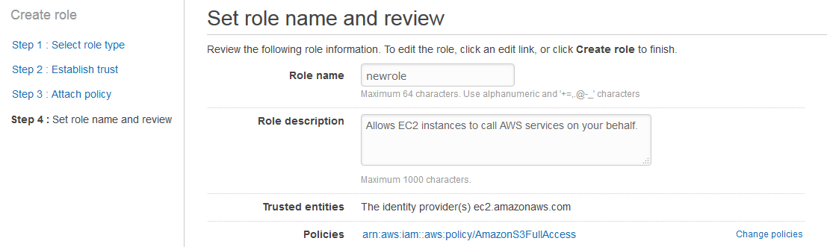

**Role created successfully.**

1. Launch t2.micro instance with Amazon Linux AMI and IAM role we created in the previous step. I am using Amazon Linux AMI, because it has awscli tools installed by default.

Note:-

While launching the machine

**In 3rd step select the IAM role created in the previous step**

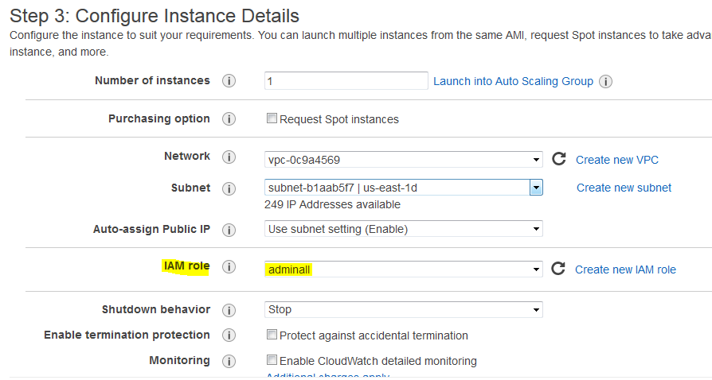

1. Allocate elastic IP (if not open network)
2. Access the Amazon AMI linux machine using putty.
3. Login as:ec2-user

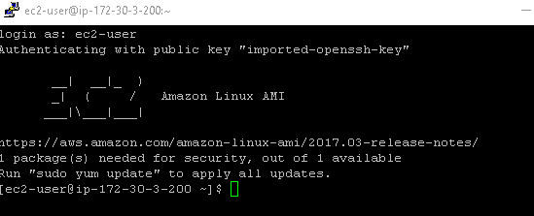

1. Execute the following commands

Run as root

* **sudo su**

install kubernetes version 1.5.x

* **wget** [**https://github.com/kubernetes/kubernetes/releases/download/v1.6.0/kubernetes.tar.gz**](https://github.com/kubernetes/kubernetes/releases/download/v1.6.0/kubernetes.tar.gz)

unzip the .tar file

* **tar -xzvf kubernetes.tar.gz**

navigate to

* **cd kubernetes/cluster/aws/**

edit config-default.sh file

* **vi config-default.sh**

And make following changes (zone , master and node size , no of nodes,s3 bucket name)

**ZONE=${KUBE_AWS_ZONE:-us-east-1d}**

**MASTER_SIZE=${MASTER_SIZE:-t2.micro}**

**NODE_SIZE=${NODE_SIZE:-t2.micro}**

**NUM_NODES=${NUM_NODES:-2}**

**AWS_S3_BUCKET=kubernetes.in**

Export kuberenets provider

* **export KUBERNETES_PROVIDER=aws**

start the cluster by kube-up.sh

* **bash cluster/kube-up.sh**

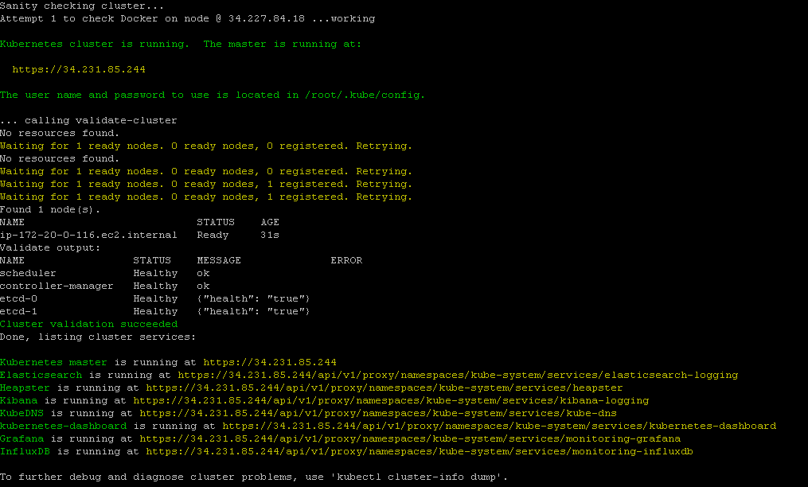

**In AWS console**

Master and minion nodes has been created



Export path

* **export PATH=/home/ec2-user/kubernetes/platforms/linux/amd64:$PATH**

To check nodes

* **Kubectl get nodes**



1. we can access Kubernetes web UI using ,https://master-public-ip/ui. It will ask for username and password which can be found in /root/.kube/config and /srv/kubernetes/basic_auth.csv files.

Finally we will get kubernetes dashboard

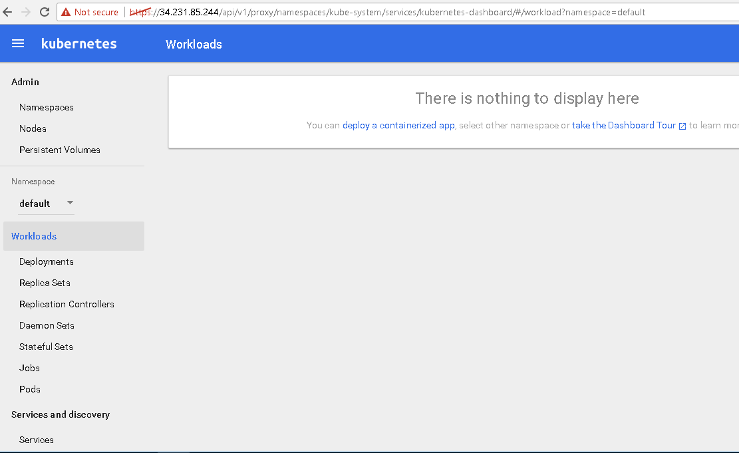

Kubernetes Installated successfully!!!

|  |  |
| --- | --- |
|  |  |
|  |  |
|  |  |
|  |  |
|  |  |